OFFICIAL COORDINATION REQUEST FOR
NON-ROUTINE OPERATIONS AND MAINTENANCE

COORDINATION TITLE- 13BON07 WS NDE LPS pump installation
COORDINATION DATE- 14 May 2013
PROJECT- Bonneville Lock and Dam
RESPONSE DATE- 17 May 2013
Description of the problem- The Corps (Sean Tackley is POC) and the University of Idaho (U of I) must install two pumps to complete the Lamprey Flume System (LFS) installed at the North Downstream Entrance of the Washington Shore Fish Ladder at Bonneville Dam. These pumps supply water to the Lamprey Passage Structure (LPS) that connects to the upstream end of the LFS. An attached memo from Ralph Budwig (U of I) provides information on the pumps and the proposed installation.

LPS pump description (from R. Budwig):
- Gould submersible pumps (x2), Model 150H05-2
- Pumps are driven by 5 hp, three phase, 460 volt motors
- Pumps are shrouded with 8 inch diameter PVC pipe. Water is drawn into the annular gap between the PVC pipe and the pump motor casing. This is required for proper cooling of the pump motor. For Bonneville the pump shroud will be extended two feet beyond the bottom of the motor.
- The wall of the 2 foot extension will have 49 three inch diameter holes drilled in it and will be entirely covered with stainless steel wire mesh with opening size of 0.088 inches. In addition, the bottom opening of the shroud will be covered with the same wire mesh. Water will be drawn in through the bottom opening and through the three inch holes – all covered with wire mesh. See Figures 1 and 2 below.

Type of outage required- Work within 50 ft of a fishway.

Impact on facility operation- N/A.

Length of time for repairs- Three days of activity (the week of 19 May); actual pump installation will take between 2 and 4 hours. Additional plumbing and electrical work to complete the system will be done using hand tools the week of 19 May as well.

Expected impacts on fish passage- No impacts on adult salmonid passage are expected as a result of these modifications, as the proposed crane and forklift operation is very brief in duration and all other work involves use of hand tools. The pumps supply water to a system that is expected to benefit adult lamprey attempting to pass the Washington Shore Fish Ladder.

Comments from Bonneville Project Fisheries------Original Message-----
From: Traylor, Andrew NWP
Sent: Tuesday, May 14, 2013 4:08 PM
To: Tackley, Sean C NWP
Cc: Mackey, Tammy M NWP; Hausmann, Ben J NWP; Budwig, Ralph; Caudill, Christopher; Bob Basham; Zobott, Hattie
Subject: RE: 13BON07 BON WA Shore flume system LPS pumps (2).doc (UNCLASSIFIED)
Sean, Our office agrees with this plan and expects minor impacts to adult salmonid passage. We will conduct all crane and heavy machinery based work starting late morning and ending no later than early afternoon to lessen any impacts.
Thanks, -Andy

Comments from agencies-
CRITFC: -----Original Message-----
From: Tom Lorz [mailto:lort@critfc.org]
Sent: Wednesday, May 15, 2013 3:10 PM
To: Mackey, Tammy M NWP
Subject: Re: FPOM: MOC 13BON07 BON WS flume system LPS pumps (UNCLASSIFIED)
Should not be a problem try to have them do any of the work that could be distributive later in the day just not early....I don't think there will be much of an impact.
Thanks tom

NOAA/NWP:
-----Original Message-----
From: Gary Fredricks - NOAA Federal [mailto:gary.fredricks@noaa.gov]
Sent: Thursday, May 16, 2013 6:58 AM
To: Mackey, Tammy M NWP
Cc: Trevor Conder - NOAA Federal; Tackley, Sean C NWP; Hausmann, Ben J NWP; Ed Meyer - NOAA Federal
Subject: Re: FPOM: MOC 13BON07 BON WS flume system LPS pumps (UNCLASSIFIED)
Tammy, A few questions for those working on this: Exactly where in relation to the NDE entrance are these to be located (how close to the actual entrance)? Do they meet NOAA screening criteria (mesh looks ok but how about through-screen velocities)? Are the 5 hp pumps themselves quiet? I see they are arriving at the dam at 9 am but when do they propose to do the actual near and in-water portion of this work?

A couple of things come to mind, for one thing you are dropping this in the entrance (apparently), right in the middle of an ongoing adult passage study. Also, with sea lions in the tailrace, it seems that any work in the entrance area sould be done at night after some of the danger of delay and increased predation has passed. We still have a good number of spring Chinook using this ladder and small things matter with a poor run like this. Thanks, Gary

-----Original Message-----
From: Tackley, Sean C NWP
Sent: Thursday, May 16, 2013 7:15 AM
To: Gary Fredricks - NOAA Federal; Mackey, Tammy M NWP; Budwig, Ralph; Bob Basham; Zobott, Hattie; Caudill, Christopher
Cc: Trevor Conder - NOAA Federal; Hausmann, Ben J NWP; Ed Meyer - NOAA Federal
Subject: RE: FPOM: MOC 13BON07 BON WS flume system LPS pumps (UNCLASSIFIED)
Hi all, Thanks for the comments, Gary. The pumps will be located at the end of the roadway deck, in the quiet water that is downstream of NDE and toward the shoreline (where the previous LPS pumps were located). I attached U of I's concept drawing of the LPS system and circled the approx. location.
Ralph and U of I team, can you please address Gary's comments and questions below?
Best, Sean
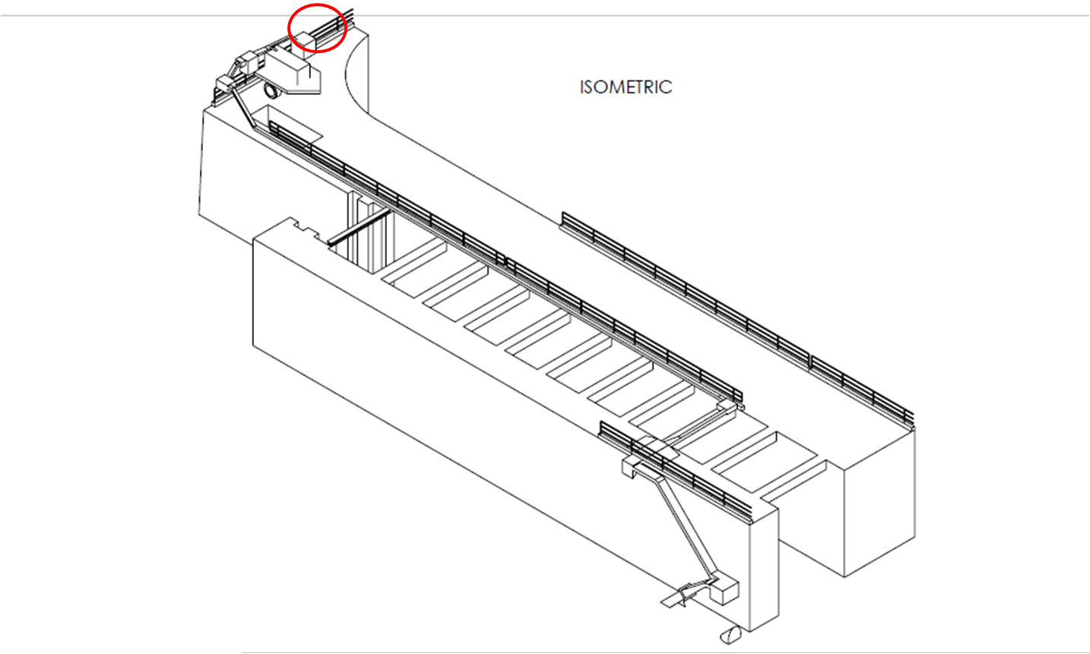

-----Original Message-----
From: Gary Fredricks - NOAA Federal [mailto:gary.fredricks@noaa.gov]
Sent: Thursday, May 16, 2013 7:31 AM
To: Tackley, Sean C NWP
Cc: Mackey, Tammy M NWP; Budwig, Ralph; Bob Basham; Zobott, Hattie; Caudill, Christopher; Trevor Conder - NOAA Federal; Hausmann, Ben J NWP; Ed Meyer - NOAA Federal
Subject: Re: FPOM: MOC 13BON07 BON WS flume system LPS pumps (UNCLASSIFIED)

Thanks Sean, That looks like a good location and alleviates most of my concerns with adult passage. I was thinking they might be placed around the corner to the left of your circle on the drawing. It would still be good to get the through-screen velocities expected with these pumps. Gary

-----Original Message-----
From: Budwig, Ralph [mailto:rbudwig@uidaho.edu]
Sent: Thursday, May 16, 2013 7:33 AM
To: gary.fredricks@noaa.gov; Mackey, Tammy M NWP
Cc: Trevor Conder - NOAA Federal; Tackley, Sean C NWP; Caudill, Christopher; Zobott, Hattie; Hausmann, Ben J NWP; Ed Meyer - NOAA Federal; Bob Basham
Subject: RE: FPOM: MOC 13BON07 BON WS flume system LPS pumps (UNCLASSIFIED)
Hello Gary and Tammy
1. Yes - I designed the pump intakes to meet the 0.2 feet/second approach velocity.
2. The pumps are standard submersible well pumps. They have a PVC pipe shroud around the pump and motor. They are the same series of pumps as used for the experimental LPS over the past few year. I am not sure of the exact noise level.
3. The actual pump installation is currently planned for early Tuesday morning (May 21st) Good day - Ralph

Ralph Budwig, PhD, PE
Professor
Center for Ecohydraulics Research
Director - College of Engineering - Boise University of Idaho
322 East Front Street, Suite 340
Boise, ID, USA 83702
208-364-4996 (W)
-----Original Message-----
From: Ed Meyer - NOAA Federal [mailto:ed.meyer@noaa.gov]
Sent: Thursday, May 16, 2013 8:27 AM
To: Budwig, Ralph; Tackley, Sean C NWP
Cc: gary.fredricks@noaa.gov; Mackey, Tammy M NWP; Trevor Conder - NOAA Federal; Caudill, Christopher; Zobott, Hattie; Hausmann, Ben J NWP; Bob Basham
Subject: Re: FPOM: MOC 13BON07 BON WS flume system LPS pumps (UNCLASSIFIED)

With regards to the screen approach velocity of 0.2 fps. Was this velocity calculated at the screen surface or was this measured in a lab. The problem with end of pump style screens is that unless there is significant internal baffling, there tends to high velocity areas on the screen face. Generally, we required that these types of screens be balanced (uniform approach flow conditions) in a lab environment (section 11.10.1.3 Passive Screens in the NMFS 2011 Guidelines - copy attached). Additionally, passive screens (screens without an active cleaning system) are limited to less than 3 cfs. Let me know if you have any questions. Ed Meyer

Final results- This action was completed as outlined below-
A few days prior to installation of the two LPS pumps near the NDE at Bonneville WA Shore last week, our engineers reviewed U of I's proposed pump bracket design and expressed concerns about the structural integrity of attaching the bracket to the curb of the tailrace deck. This prompted dialogue among our staff and the U of I engineers on how to best facilitate safe and secure attachment of the pumps while still allowing periodic removal for inspecting and servicing the pumps. We agreed on a two-phase plan:

1. Devise a temporary, 1-pump operation (with a second pump on site in the event of a failure) that uses a flex hose and anchor/zip-line approach similar to the system used for the previous (NOAA) LPS at this location. This system would be in operation for the 2013 season and will be deployed next week (5/29). See attached Word doc from U of I on the general design and a revised memo on installation from Ralph Budwig (PDF). Note that no crane support is required for deployment of the pump, though they will need to install 4 bolts each for a davit and a cable spool/winch.

2. In coordination with U of I, Portland District engineers will design a more permanent system. Because it is important to have access to the pumps for cleaning and inspection, the current thinking is that we may be able to use an i-beam/trolley/flex hose system. This "permanent" system would be installed at a later date - likely in parallel with any Lamprey Flume System hanging rod repairs.

As you know, we need this pump operating to supply water to the LPS at the top of the Lamprey Flume System. Between this and other final fit and finish issues with the LPS, operation of the Lamprey Flume System has been delayed more than we would have liked. The plan was to have this entire system running by mid-May. If we can deploy the LPS pump and get any and all remaining touch up completed on 5/29, we should have an operating Lamprey Flume System on 5/30 (Yay!!).

Thanks for your patience and interest, and kudos to the folks from U of I and the Corps who have helped to get the system up and running ASAP. We are all anxious to get this system going!

Best Regards,
Sean

Please email or call with questions or concerns:
Sean C. Tackley
503-808-4751
sean.c.tackley@usace.army.mil
To: Sean Tackley (USACE Portland District) From: Ralph Budwig (UI Boise, CER)
Date: May 14, 2013
Subject: Bonneville LPS pumps and pump installation

1. Photo and specifications of pump
There are two identical pumps with one being a backup to the other. The pumps are wired and plumbed independently. Only one pump will be operated at a time. Each pump is a Gould submersible pump, Model 150H05-2. A photo of the pump and the pump curve are shown below. The pump is driven by a
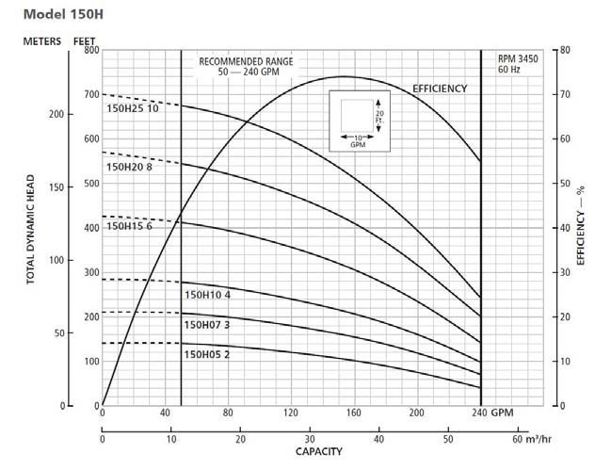
5 hp, three phase, 460 volt motor.

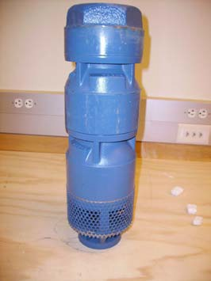

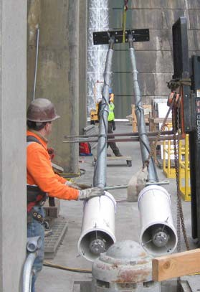
2. Pump intake with screening.
The pumps are shrouded with 8 inch diameter PVC pipe. A photo of the pump shrouds used at John Day Dam is shown to the right. You can see the bottom of the pump motor casing through the bottom opening of the shroud. Water is drawn into the annular gap between the PVC pipe and the pump motor casing. This is required for proper cooling of the pump motor. For Bonneville the pump shroud will be extended two feet beyond the bottom of the motor. The wall of the two foot extension will have 49 three inch diameter holes drilled in it and will be entirely covered with stainless steel wire mesh with opening size of 0.088 inches. In addition, the bottom opening of the shroud will be covered with the same wire mesh. Water will be drawn in through the bottom opening and through the three inch holes – all covered with wire mesh. A photo of the pump shroud with screening is shown on the next page
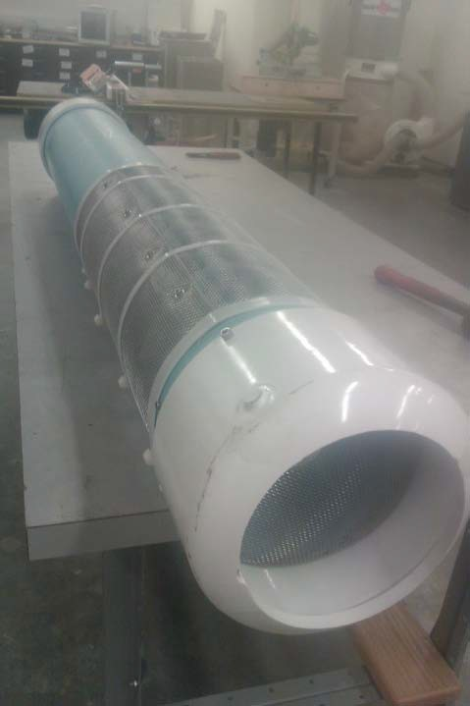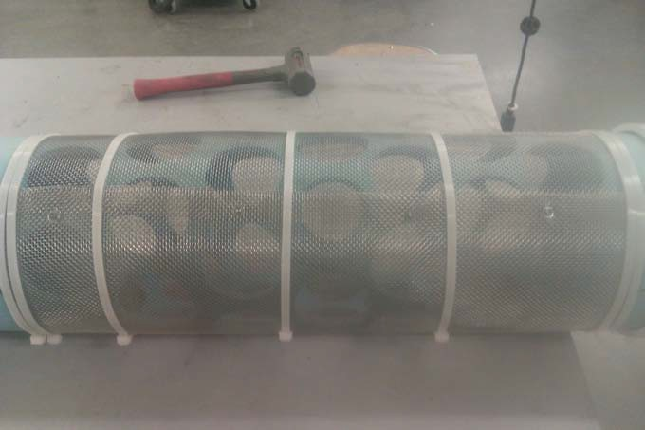

3. Pump mounting brackets.
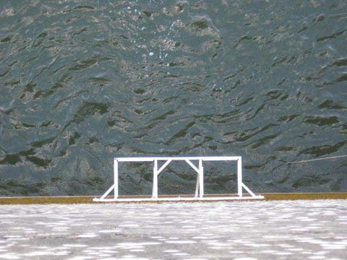
The pump pass through bracket has been installed on the West wall of the fish ladder and shown in the photo to the right. Pump one will pass through the left aperture and pump 2 through the right aperture. The brackets that suspend the pump pipe have been fabricated but have not been installed. They will be mounted on the curb (at deck level) directly above the pass through bracket – one bracket for each pump. We will need to drill holes for anchors to install the mounting brackets into the curb at the deck level.

4. Pump Installation.
We plan to arrive to Bonneville Dam at 8 am on May 20. We will assemble the pumps and pipes on the deck on May 20 (no support required but need rigger to advise on pipe and pump placement on the deck). This should be a quiet operation - moving pump and pipe by hand and using hand tools to do the assembly. On May 21 we will be joined by the USACE crane and fork lift operators to install the pumps. The process will very similar to the John Day installation shown below. The only noise involved will be the engine noise and road noise of the crane and fork lift. After the pumps are in place will need to drill anchor holes in the concrete curb at deck level. The remainder of the work will be done on May 21 and May 22 (plumbing and electrical at deck level) with hand tools and should be quiet.

